01. Call Me A Taxi
Environment Specifics
Please be aware that every JS environment may behave differently when executing code. Certain things that work in the browser are not supported in Node.js, which is the environment used by Judge.
The following actions are NOT supported:
- .forEach() with NodeList (returned by querySelector() and querySelectorAll())
- .forEach() with HTMLCollection (returned by getElementsByClassName() and element.children)
- Using the spread-operator (...) to convert a NodeList into an array
- append() in Judge (use only appendChild())
- prepend()
- replaceWith()
- replaceAll()
- closest()
- replaceChildren()
- Always turn the collection into a JS array (forEach, forOf, et.)
If you want to perform these operations, you may use Array.from() to first convert the collection into an array.

Your Task
Use the provided skeleton to solve this problem.

Functionality
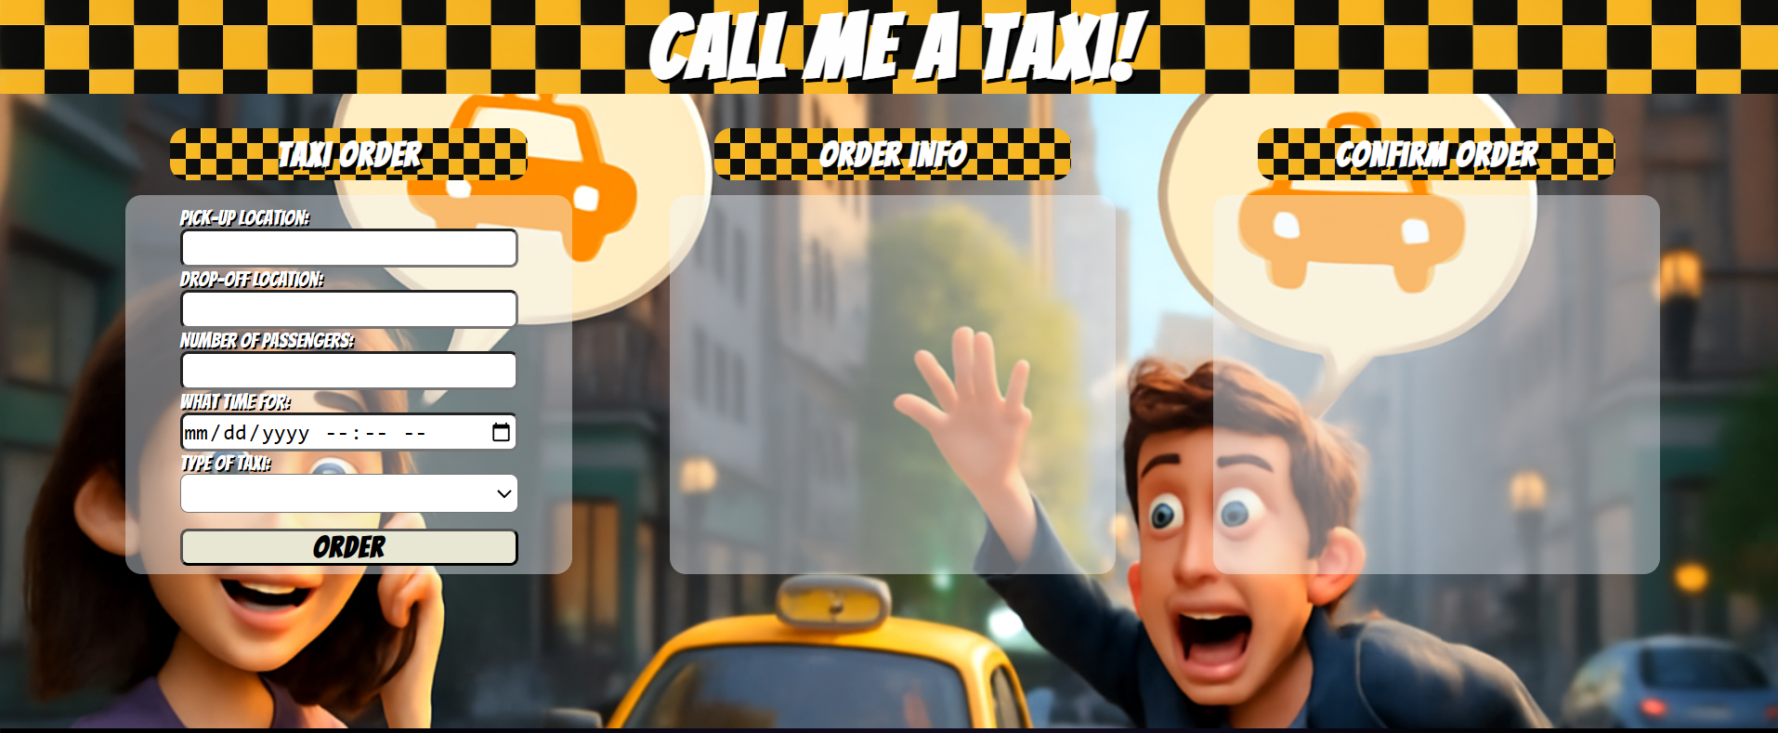
Write the missing functionality of this user interface. The functionality is divided in the following steps:
Write the missing JavaScript code to make the Taxi Order work as expected:
All fields (Pick-up Location, Drop-off Location, Number of Passengers, What time for and Type of Taxi) are filled with the correct input
- Pick-up Location, Drop-off Location, Number of Passengers, What time for and Type of Taxi are non-empty strings. If any of them is empty, the program should not do anything.
- Getting the information from the form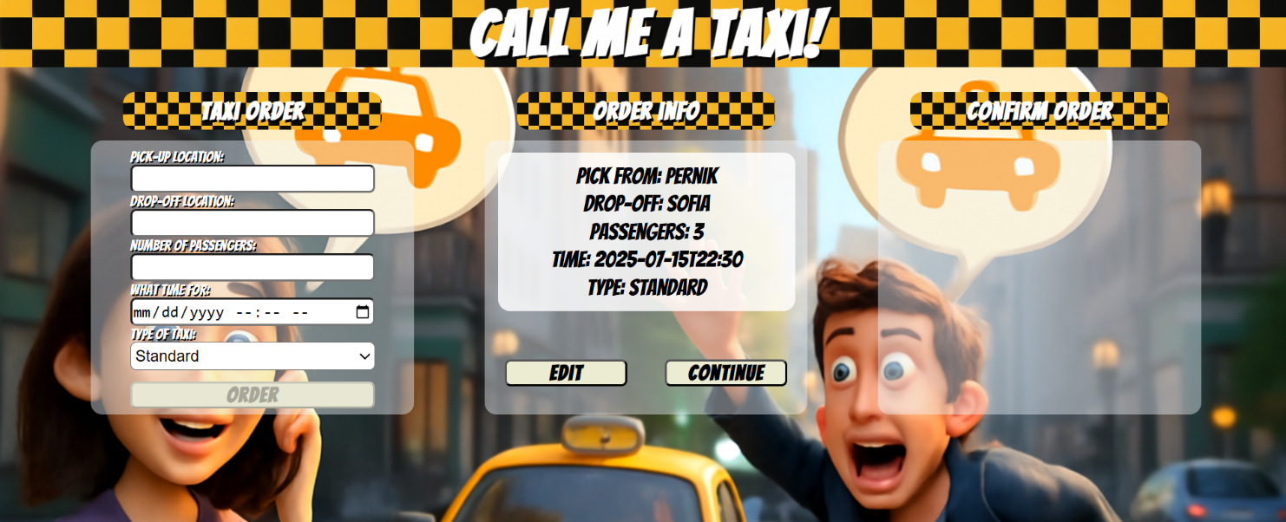
- On clicking the ["Order"] button the information from the input fields is listed in the "Order info" section. For the input fields a list item is added to the "order-info-list" unordered list.
- The text format and order for the list item should be the same as on the picture below.
- When the button is clicked, the input fields must be cleared and the ["Order"] button must be disabled. At the same time the ["Edit"] and the ["Continue"] buttons must be added.
The HTML structure looks like this:
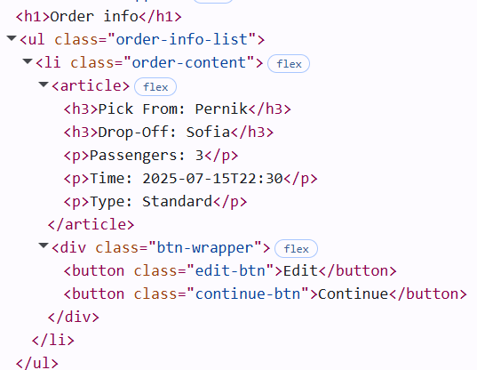
- Edit
The functionality here is the following:
- When the "Edit" button is clicked, all of the information is loaded in the input fields from step 1 and all buttons in preview section are removed while the ["Order"] button is enabled again.
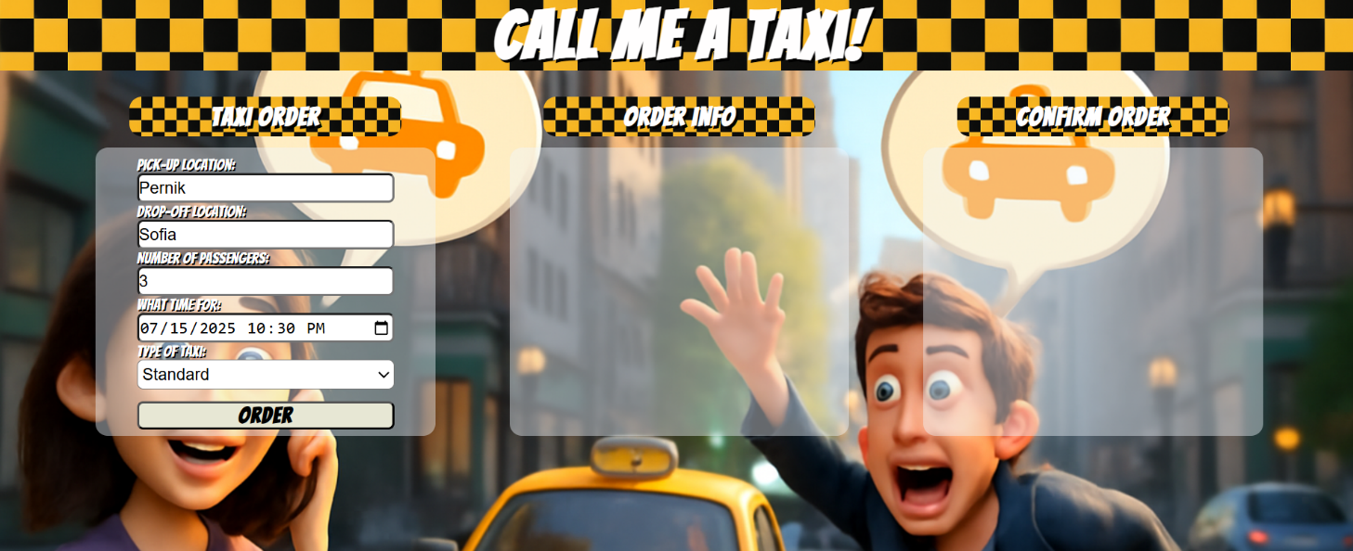
- The list items must be removed from the "order-info-list" and all of the information must go back to the input fields again.
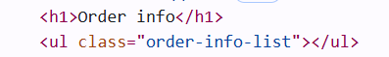
- Continue
- When the ["Continue"] button is clicked, the information from "order-info-list" unordered list must be transferred to "confirm-list" in the same HTML structure. For you, this means removing everything inside of the ul with class = "order-info-list" and adding in "confirm-order-list", the list item with same information and ["Confirm"] and the ["Cancel"] buttons must be added.
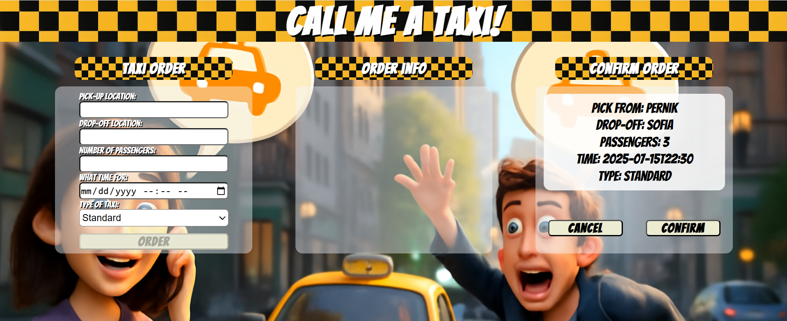
- This is HTML structure of "confirm-order-list" unordered list:
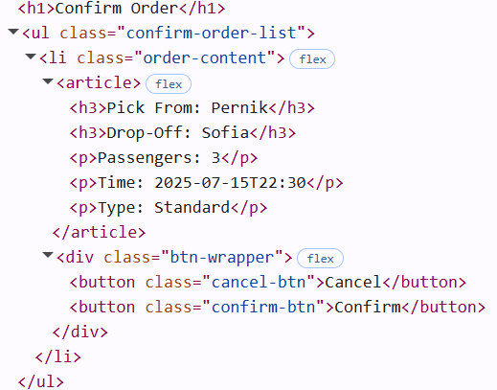
- Confirm/Cancel
- When the ["Confirm"] or ["Cancel"] button is clicked, the list item must be removed, from the "confirm-order-list", the ["Order"] button is enabled again you must add new class and add text to <h1> element with id="status".If ["Confirm"] button is clicked class must be " taxi-ordered" and text is "Taxi has been successfully ordered.". If ["Cancel"] button is clicked class must be "taxi-not-complete" and text is "Taxi request was not completed.".
["Confirm"] button:
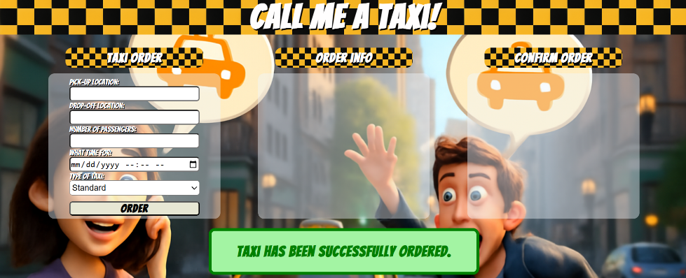
["Cancel"] button:
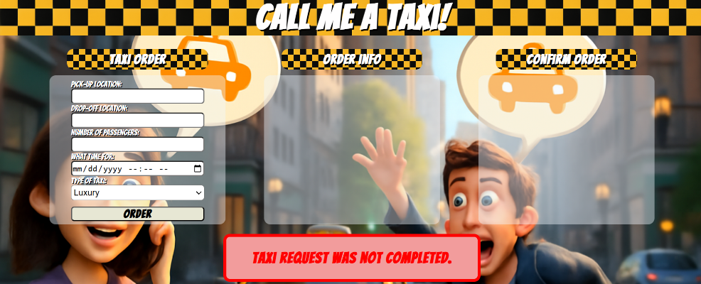
- Reload
- On clicking the <h1> element with id="status", you must reload the page.

Submission
Submit only yours solve() function.

GOOD LUCK…

